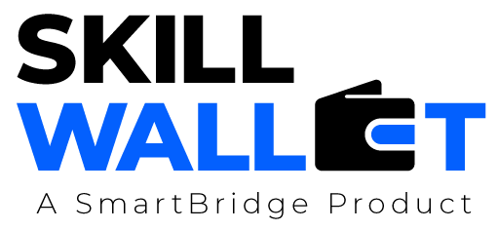

Communication

Date | 01 July 2026
Team ID | XXXXXX
Project Name | OptiCrop: Smart Agricultural Production Optimization Engine
Maximum Marks | 1 Mark

Communication Plan:
Effective communication is essential for a successful project demonstration. This document outlines the communication strategy used within the team and with stakeholders throughout the project lifecycle, including how updates, issues, and feedback were managed.

S.No | Communication Type | Frequency | Channel / Tool | Participants | Purpose
1 | Team Standup | Daily | WhatsApp / Google Meet | All Team Members | Discuss daily tasks and progress
2 | Progress Update | Weekly | Skill Wallet / GitHub | Team Lead & Members | Track project milestones
3 | Issue / Bug Discussion | As Needed | WhatsApp / GitHub Issues | Development Team | Resolve technical issues
4 | Stakeholder Review | Bi-Weekly | Google Meet | Mentor & Team | Review project status and feedback
5 | Final Demo Rehearsal | Once | Google Meet | Entire Team | Prepare for final presentation
6

Communication Challenges & Resolutions:
S.No | Challenge Faced | Resolution / Action Taken
1 | Difficulty coordinating team schedules | Used WhatsApp and Google Meet to schedule meetings.
2 | Merge conflicts in GitHub | Reviewed commits and resolved conflicts collaboratively.
3 | Requirement changes during development | Conducted team discussions and updated documentation promptly.

